Multitasking: Executing several tasks simultaneously is the concept of multitasking. There are two types of multitasking's.
- Process based multitasking.
- Thread based multitasking.

Process based multitasking:
Executing several tasks simultaneously where each task is a separate independent process such type of multitasking is called process based multitasking. Example:
- While typing a java program in the editor we can able to listen mp3 audio songs at the same time we can download a file from the net all these tasks are independent of each other and executing simultaneously and hence it is Process based multitasking.
- This type of multitasking is best suitable at "os level".
Thread based multitasking:
Executing several tasks simultaneously where each task is a separate independent part of the same program, is called Thread based multitasking. And each independent part is called a "Thread".
- This type of multitasking is best suitable for "programatic level".
- When compared with "C++", developing multithreading examples is very easy in java because java provides in built support for multithreading through a rich API (Thread, Runnable, ThreadGroup, ThreadLocal...etc).
- In multithreading on 10% of the work the programmer is required to do and 90% of the work will be down by java API.
- The main important application areas of multithreading are:
  - To implement multimedia graphics.
  - To develop animations.
  - To develop video games etc.
  - To develop web and application servers
- Whether it is process based or Thread based the main objective of multitasking is to improve performance of the system by reducing response time.

We can define a Thread in the following 2 ways.
1. By extending Thread class.
2. By implementing Runnable interface.

Defining a Thread by extending "Thread class":
Example:

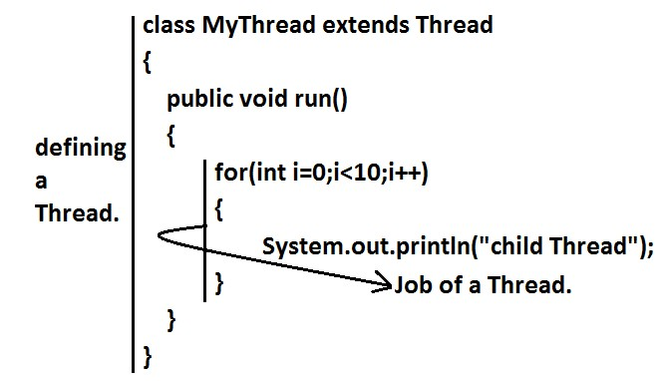

class ThreadDemo
{ public static void main(String[] args)
{
MyThread t=new MyThread();//Instantiation of a Thread t.start();//starting of a Thread

for(int i=0;i<5;i++)
{
System.out.println("main thread");
}
}

Difference between t.start() and t.run() methods.
- In the case of t.start() a new Thread will be created which is responsible for the execution of run() method.
- But in the case of t.run() no new Thread will be created and run() method will be executed just like a normal method by the main Thread.

If we are not overriding run() method:
If we are not overriding run() method then Thread class run() method will be executed which has empty implementation and hence we won't get any output.
Example: class MyThread extends Thread
{}
class ThreadDemo
{
public static void main(String[] args)
{
MyThread t=new MyThread();
t.start();
}
}

Overloding of run() method.
We can overload run() method but Thread class start() method always invokes no argument run() method the other overload run() methods we have to call explicitly then only it will be executed just like normal method.
Example: class MyThread extends Thread
{
public void run()
{
System.out.println("no arg method");
}
public void run(int i)
{
System.out.println("int arg method");
}
}
class ThreadDemo
{
public static void main(String[] args)
{
MyThread t=new MyThread();
t.start();
}
} Output:
No arg method

overriding of start() method:
If we override start() method then our start() method will be executed just like a normal method call and no new Thread will be started.
Example:
class MyThread extends Thread
{
public void start()
{
System.out.println("start method");
}
public void run()
{
System.out.println("run method");
}
} class ThreadDemo
{
public static void main(String[] args)
{
MyThread t=new MyThread();
t.start();
System.out.println("main method");
}
} Output:
start method main method
Entire output produced by only main Thread.
Note : It is never recommended to override start() method.

life cycle of the Thread:
Diagram:

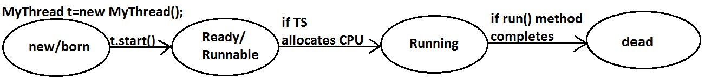

- Once we created a Thread object then the Thread is said to be in new state or born state.
- Once we call start() method then the Thread will be entered into Ready or Runnable state.
- If Thread Scheduler allocates CPU then the Thread will be entered into running state.
Once run() method completes then the Thread will entered into dead state

Defining a Thread by implementing Runnable interface:
We can define a Thread even by implementing Runnable interface also.
Runnable interface present in java.lang.pkg and contains only one method run().

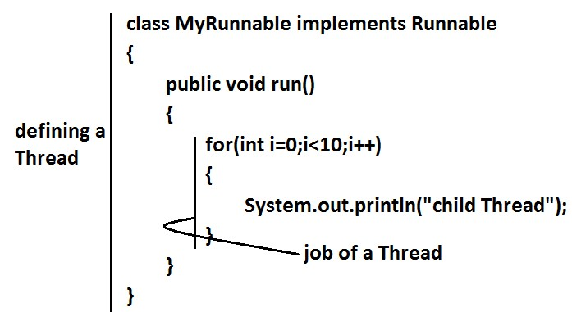

class ThreadDemo
{
public static void main(String[] args)
{
MyRunnable r=new MyRunnable();
Thread t=new Thread(r);//here r is a Target Runnable
t.start();

for(int i=0;i<10;i++)
{
System.out.println("main thread");
}
}
} Output: main thread main thread main thread main thread main
We can't expect exact output but there are several possible outputs.
MyRunnable r=new MyRunnable();
Thread t1=new Thread(); Thread t2=new Thread(r);
Best approach to define a Thread:
- Among the 2 ways of defining a Thread, implements Runnable approach is always recommended.
- In the 1st approach our class should always extends Thread class there is no chance of extending any other class hence we are missing the benefits of inheritance.
- But in the 2nd approach while implementing Runnable interface we can extend some other class also. Hence implements Runnable mechanism is recommended to define a Thread.

Join():
If a Thread wants to wait until completing some other Thread then we should go for join() method.
Example: If a Thread t1 executes t2.join() then t1 should go for waiting state until completing t2.

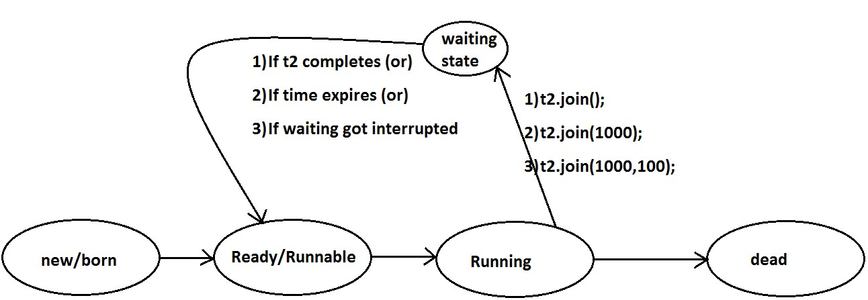

Every join() method throws InterruptedException, which is checked exception hence compulsory we should handle either by try catch or by throws keyword.
Otherwise we will get compiletime error.
Example: class MyThread extends Thread
{
public void run()
{
for(int i=0;i<5;i++)
{
System.out.println("Sita Thread"); try
{
Thread.sleep(2000);
}
catch (InterruptedException e){}
}
}
} class ThreadJoinDemo
{
public static void main(String[] args)throws InterruptedException
{
MyThread t=new MyThread();
t.start();
//t.join(); //--->1
for(int i=0;i<5;i++)
{
System.out.println("Rama Thread");
}
}

- If we are commenting line 1 then both Threads will be executed simultaneously and we can't expect exact execution order.
- If we are not commenting line 1 then main Thread will wait until completing child Thread in this the output is sita Thread 5 times followed by Rama Thread 5 times.

Waiting of child Thread untill completing main Thread :
Example: class MyThread extends Thread
{ static Thread mt;
public void run()
{
try
{
mt.join();
}
catch (InterruptedException e){}

for(int i=0;i<5;i++)
{
System.out.println("Child Thread");
}
}
} class ThreadJoinDemo
{
public static void main(String[] args)throws InterruptedException
{
MyThread mt=Thread.currentThread(); MyThread t=new MyThread();
t.start();

for(int i=0;i<5;i++)
{
Thread.sleep(2000);
System.out.println("Main Thread");
}
}
}

Output :

Main Thread
Main Thread
Main Thread

Main Thread
Main Thread
Child Thread
Child Thread
Child Thread
Child Thread
Child Thread

Sleep() method:
If a Thread don't want to perform any operation for a particular amount of time then we should go for sleep() method.
- public static native void sleep(long ms) throws InterruptedException
- public static void sleep(long ms,int ns)throws InterruptedException

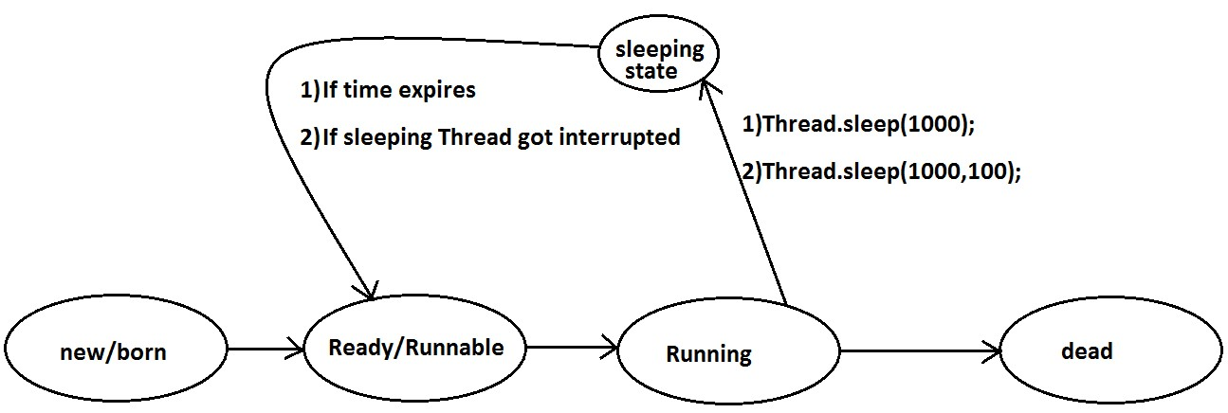

two-argument version of Thread.sleep (Thread.sleep(long millis, int nanos)) comes down to precision and flexibility in expressing time durations.

Example:
class ThreadJoinDemo
{ public static void main(String[] args)throws InterruptedException
{
System.out.println("M");
Thread.sleep(3000);
System.out.println("E");
Thread.sleep(3000);
System.out.println("G");
Thread.sleep(3000);
System.out.println("A");
}
} Output:
M
E
G
A

Synchronization

- Synchronized is the keyword applicable for methods and blocks but not for classes and variables.
- If a method or block declared as the synchronized then at a time only one Thread is allow to execute that method or block on the given object.
- The main advantage of synchronized keyword is we can resolve date inconsistency problems.
- But the main disadvantage of synchronized keyword is it increases waiting time of the Thread and effects performance of the system.
- Hence if there is no specific requirement then never recommended to use synchronized keyword.
- Internally synchronization concept is implemented by using lock concept.
- Every object in java has a unique lock. Whenever we are using synchronized keyword then only lock concept will come into the picture.
- If a Thread wants to execute any synchronized method on the given object 1st it has to get the lock of that object. Once a Thread got the lock of that object then it's allow to execute any synchronized method on that object. If the synchronized method execution completes then automatically Thread releases lock.
- While a Thread executing any synchronized method the remaining Threads are not allowed execute any synchronized method on that object simultaneously. But remaining Threads are allowed to execute any non-synchronized method simultaneously. [lock concept is implemented based on object but not based on method].

Example:
class Display
{
public synchronized void wish(String name)
{
for(int i=0;i<5;i++)
{
System.out.print("good morning:");
try
{
Thread.sleep(1000);
}
catch (InterruptedException e)
{}
System.out.println(name);
}
}
} class MyThread extends Thread

{
Display d;
String name;
MyThread(Display d,String name)
{
this.d=d;
this.name=name;
}
public void run()
{
d.wish(name);
}
} class SynchronizedDemo
{
public static void main(String[] args)
{
Display d1=new Display();
MyThread t1=new MyThread(d1,"dhoni"); MyThread t2=new MyThread(d1,"yuvaraj"); t1.start(); t2.start();
}
}
If we are not declaring wish() method as synchronized then both Threads will be executed simultaneously and we will get irregular output.
Output: good morning:good morning:yuvaraj good morning:dhoni good morning:yuvaraj good morning:dhoni good morning:yuvaraj good morning:dhoni good morning:yuvaraj good morning:dhoni good morning:yuvaraj dhoni
If we declare wish()method as synchronized then the Threads will be executed one by one that is until completing the 1st Thread the 2nd Thread will wait in this case we will get regular output which is nothing but
Output:
good morning:dhoni good morning:dhoni good morning:dhoni good morning:dhoni good morning:dhoni good morning:yuvaraj good morning:yuvaraj good morning:yuvaraj good morning:yuvaraj

